**PROJECT REPORT**

**IMPLEMENTING CRM FOR RESULT TRACKING OF A CANDIDATE WITH INTERNAL MARKS**

* 1. **INTRODUCTION**
  2. **Overview**

Administrator should be able to create all base data including semester ,candidate ,course and lecturer , lecturer should have the ability to create internal results ,dean, who is one of the lecturer ,should be the only one with ability to update internal results ,re-evaluation can be initialized by candidate for all internal results.

* 1. **Purpose**

A CRM system can help you maintain a centralized data base of all the interaction with the candidate , making it easy to access and analyze the data .

By tracking the candidate’s results and performance over time , you can monitor their progress and identify areas where they may need additional support or resources .

2 Problem Definition & Design Thinking

**2.1 Empathy Map**

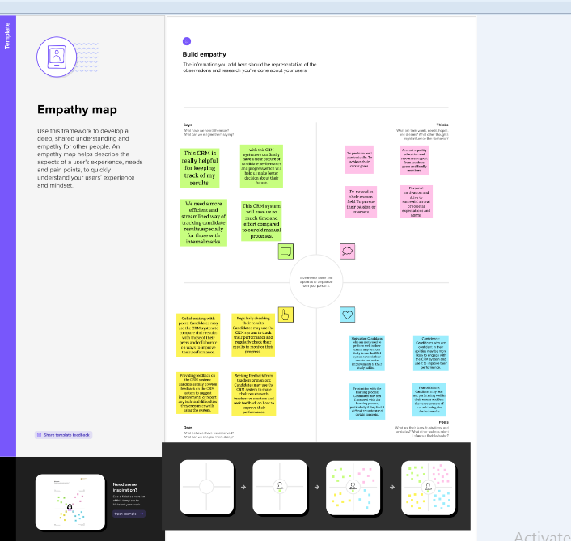

**2.2 Ideation & Brainstorming Map**

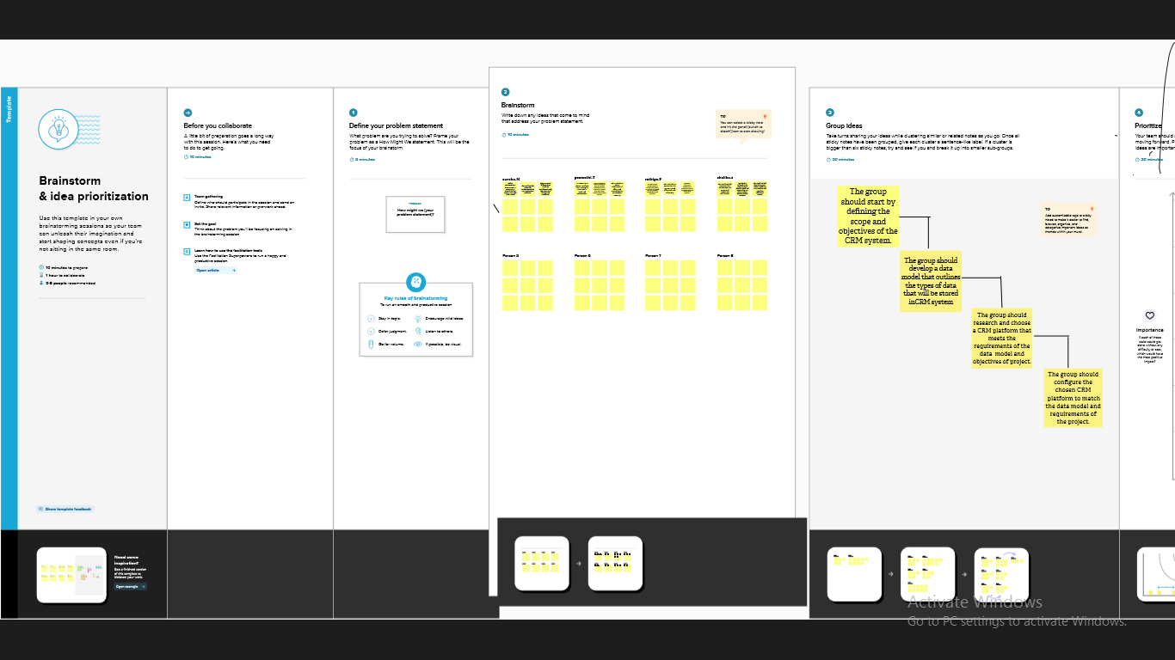

**3 RESULT**

3.1 Data Model:

|  |  |
| --- | --- |
| **OBJECT NAME** | **FIELDS IN THE OBJECT** |
| Semester | |  |  | | --- | --- | | **FIELD LABEL** | **DATA TYPE** | | Semester name | Text | | course | date | |

|  |  |
| --- | --- |
| **OBJECT NAME** | **FIELDS IN THE OBJECT** |
| Candidate | |  |  | | --- | --- | | **FIELD LABEL** | **DATA TYPE** | | Candidate name | text | | Candidate id | date | | Semester name | date | | Internal results | date | |
| Course details | |  |  | | --- | --- | | **FIELD LABEL** | **DATA TYPE** | | Course name | Date | | Course id | Date | |
| Lecturer details | |  |  | | --- | --- | | **FIELD LABEL** | **DATA TYPE** | | Lecturer role | Date | | Lecturer name | Date | | Course id | Date | | course | Date | |
| Internal results | |  |  | | --- | --- | | **FIELD LABEL** | **DATA TYPE** | | Candidate id | Date | | Course Id | Date | | Marks | Date | |

**3.2 Activity & Screenshot**

Creating my developer account and account activation and login to my salesforce account.

**Milestone 1**

To create an object

1. Semester
2. Candidate
3. Course details
4. Lecturer details
5. Internal results

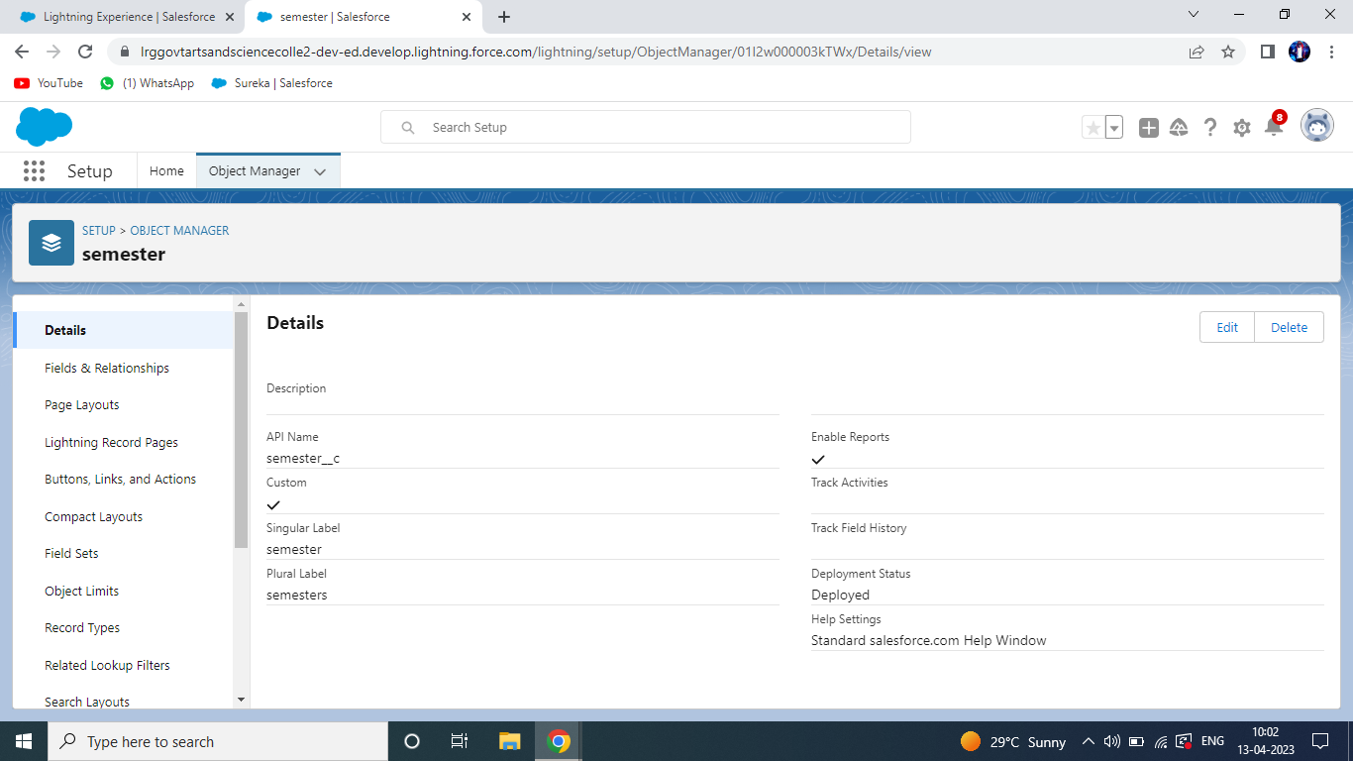

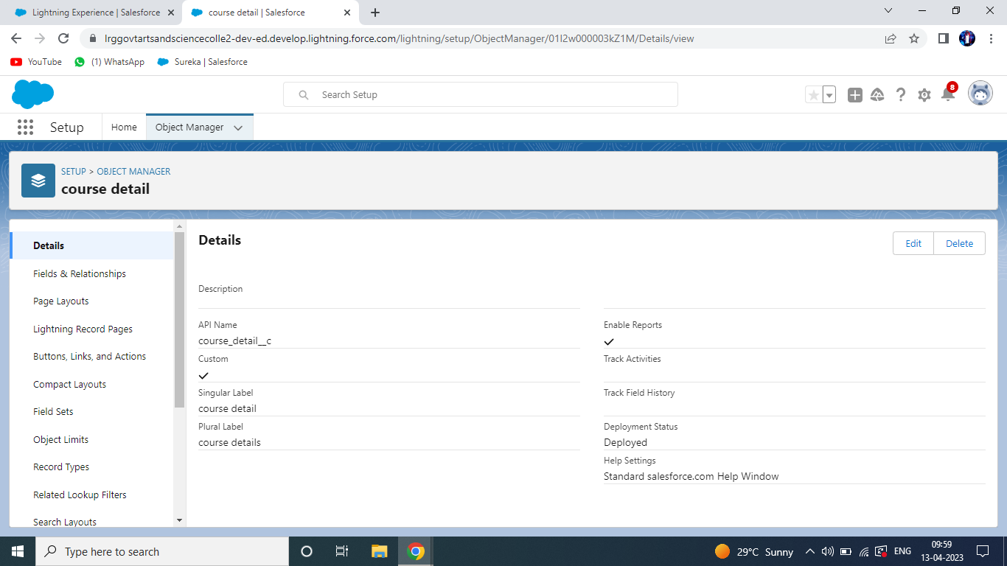

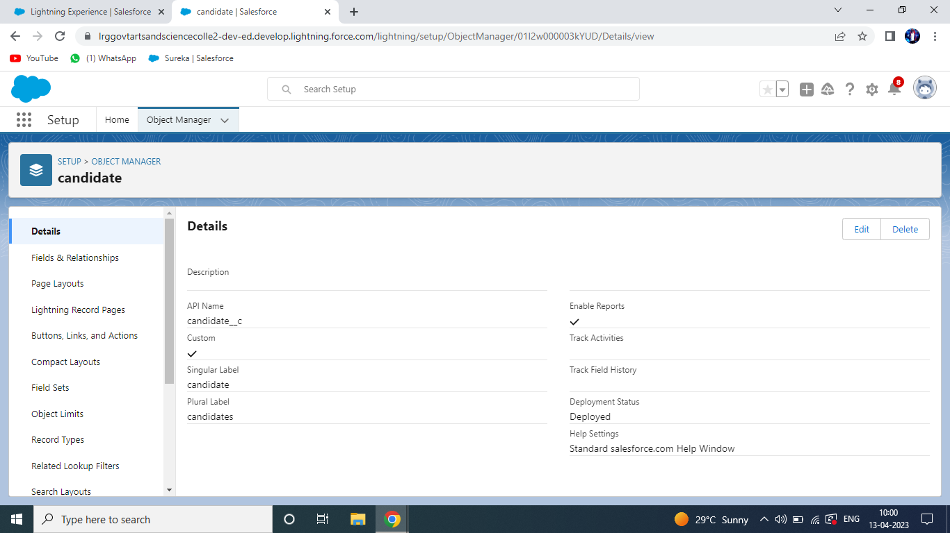

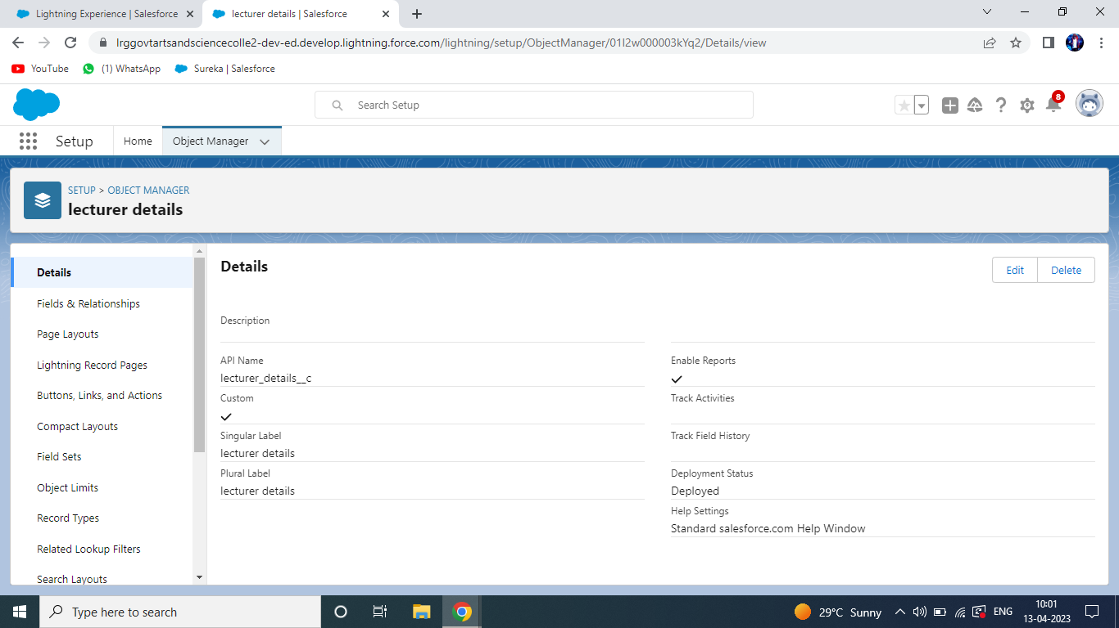

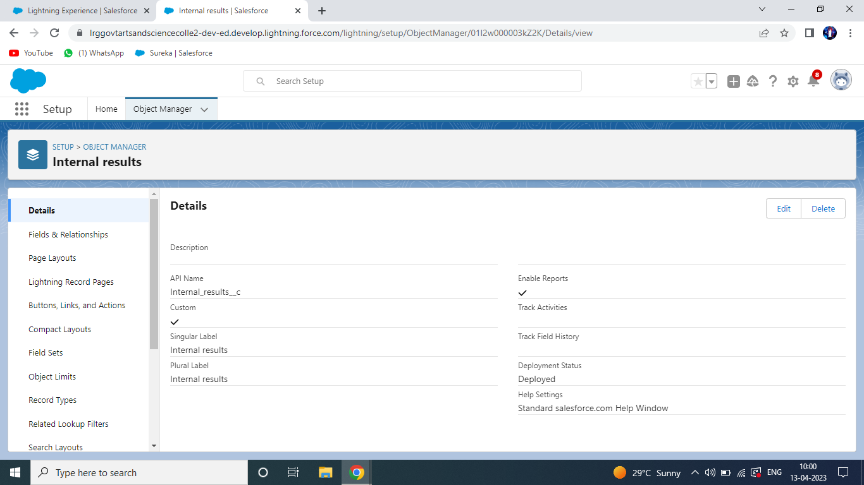

**MILESTONE 2**

Field and relationship

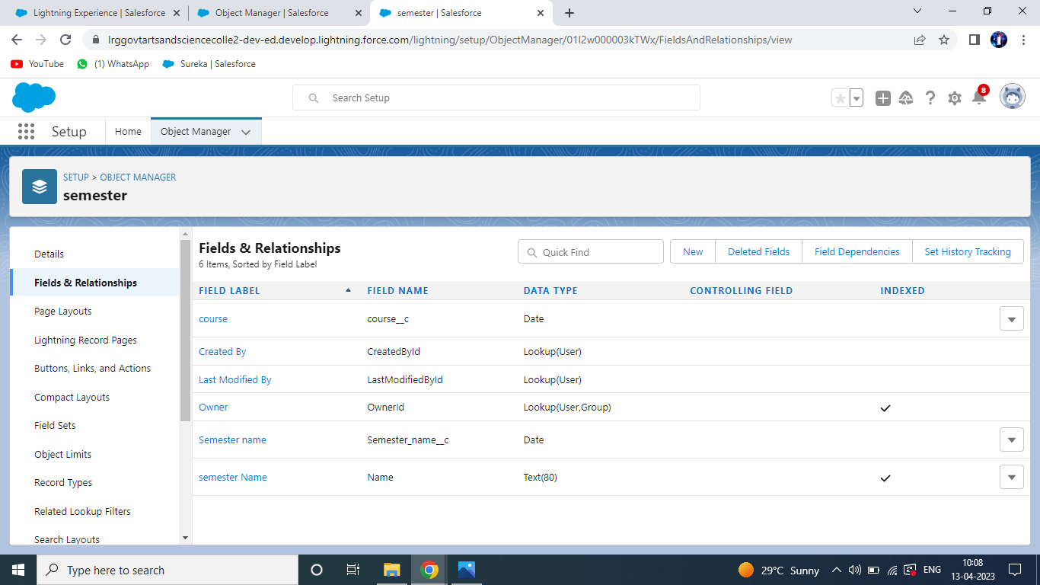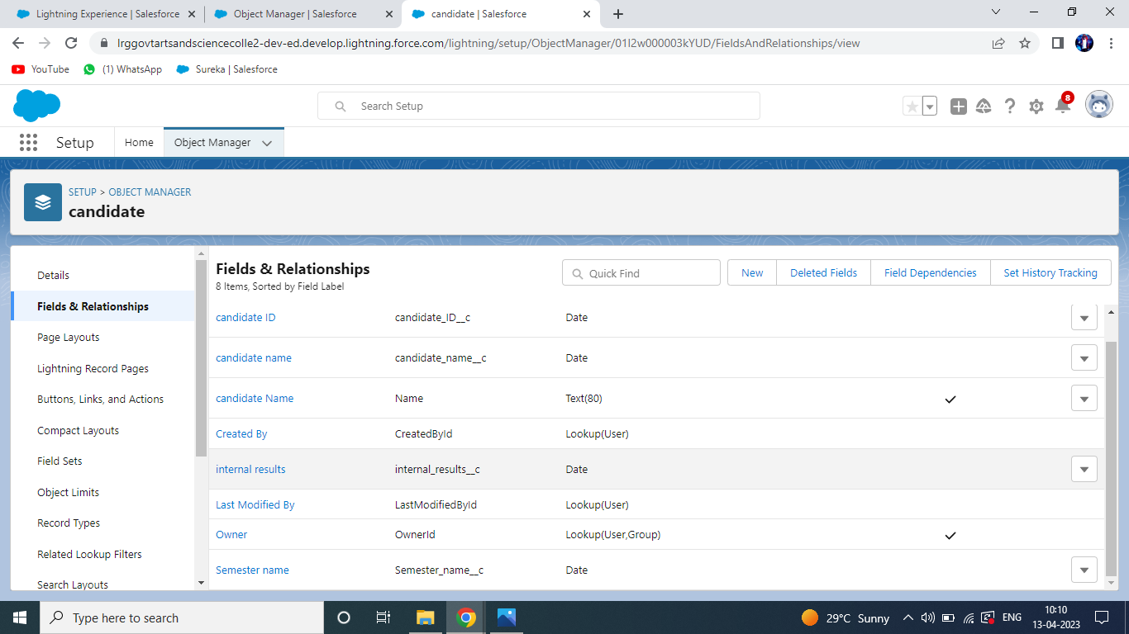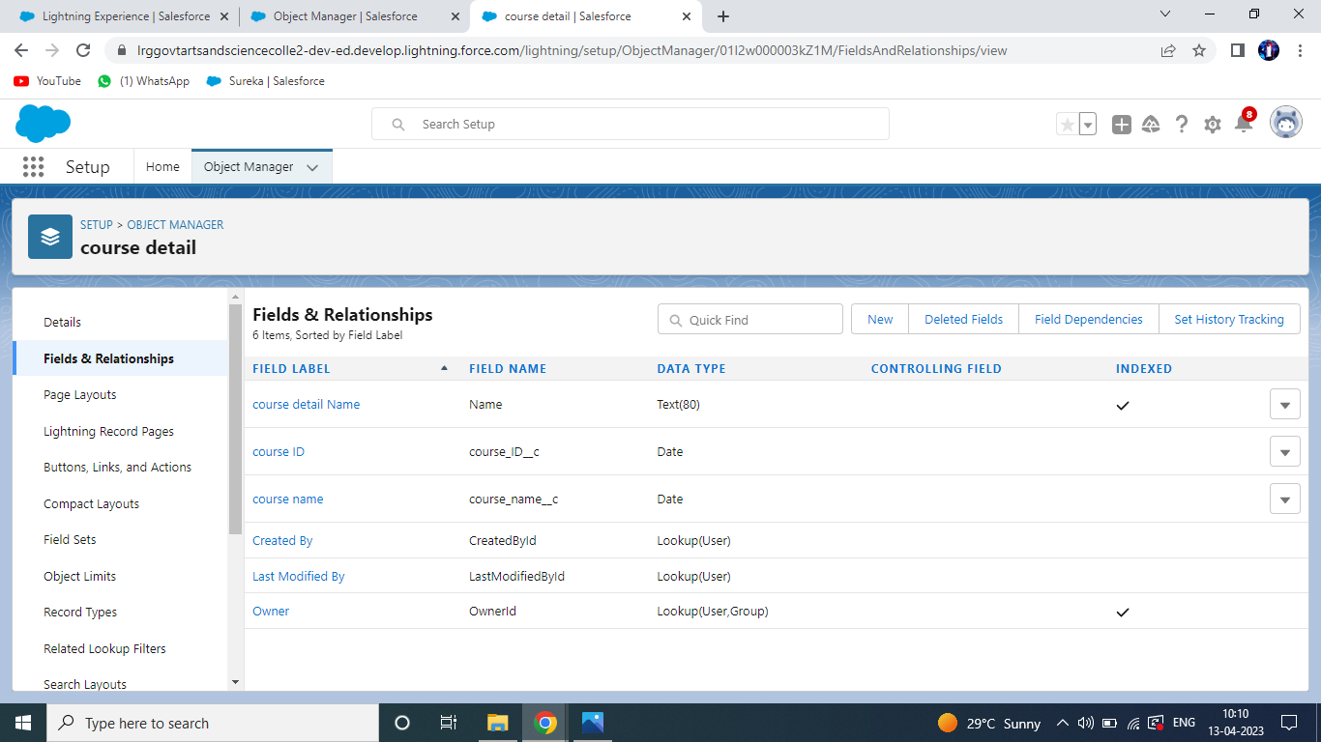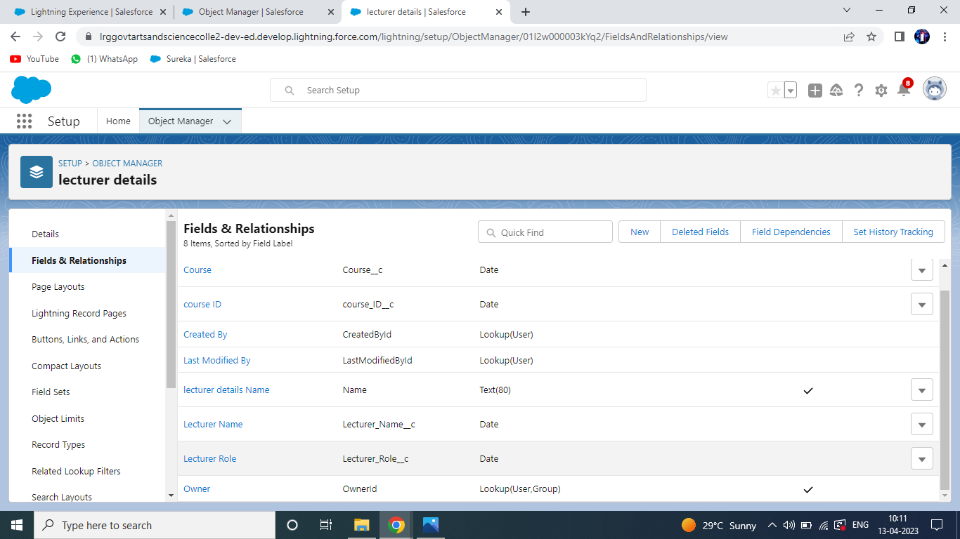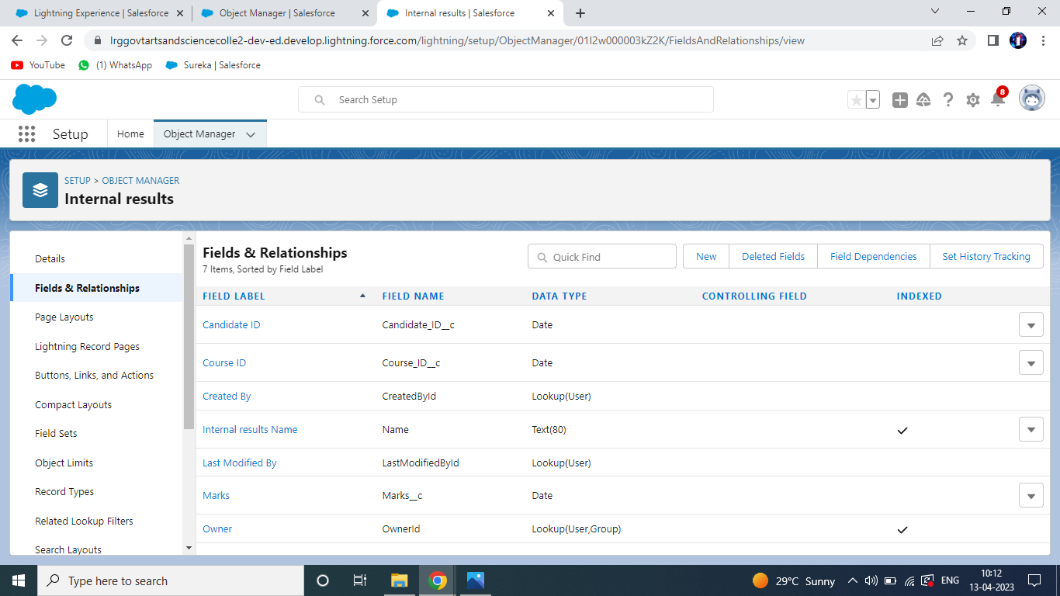

**MILESTONE 3**

Lightning app

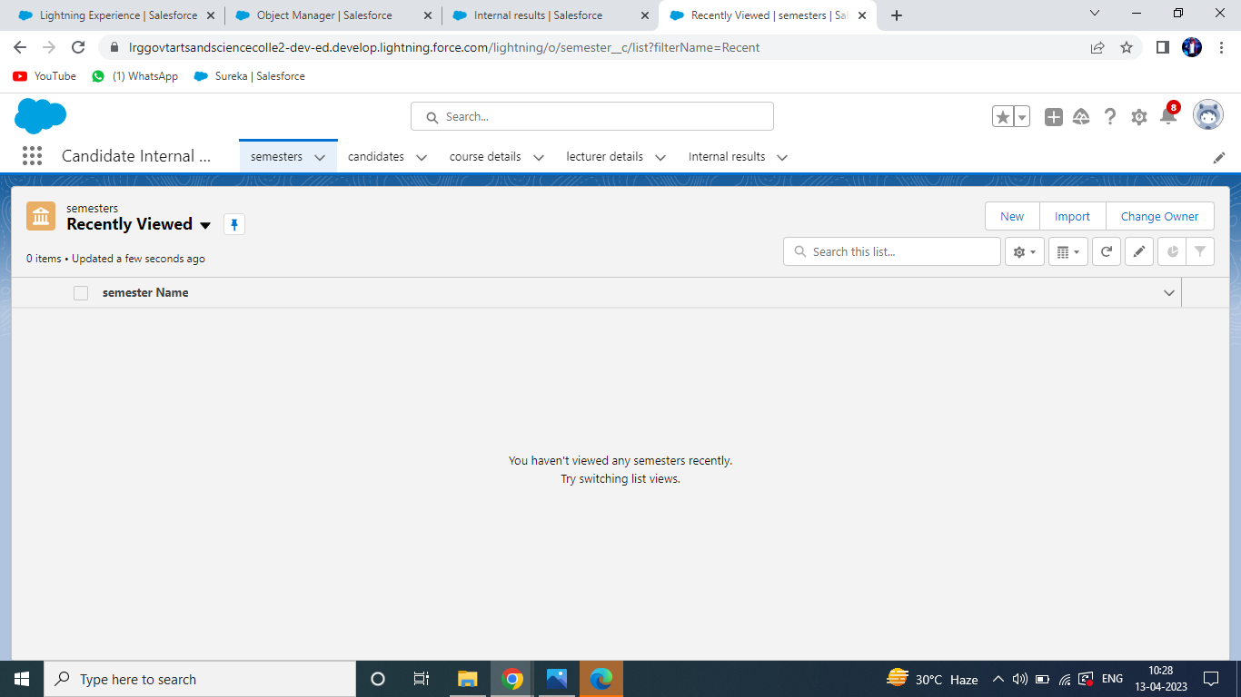

**MILESTONE 4**

Users

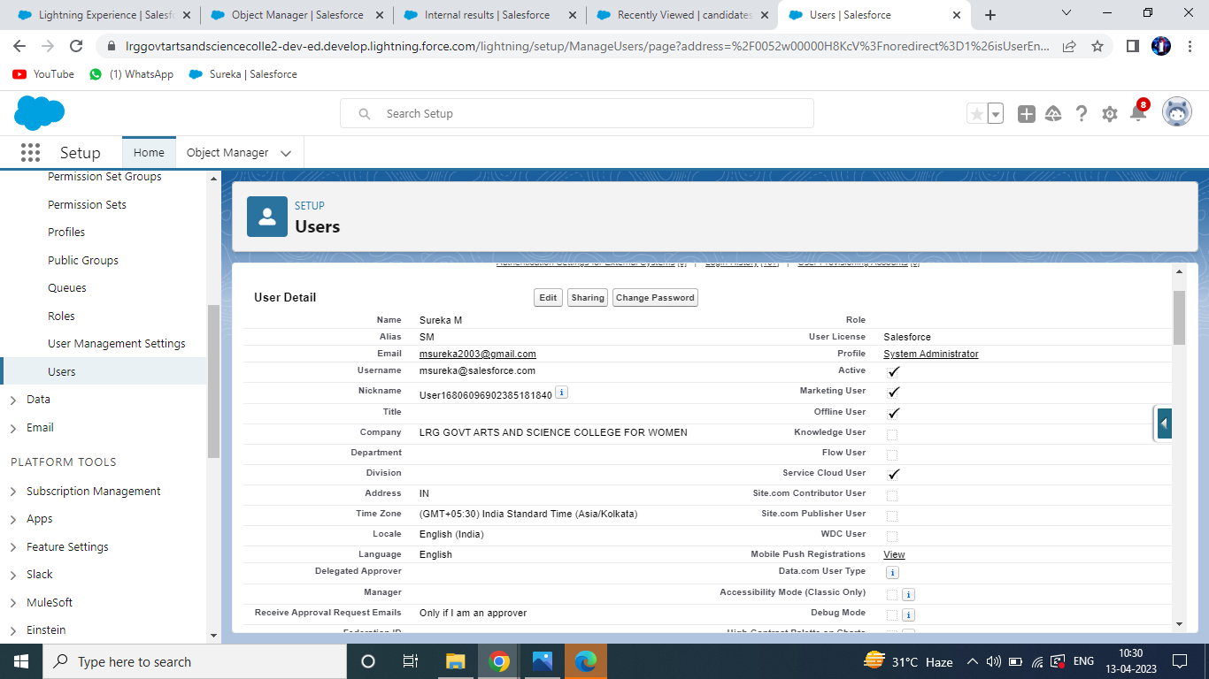

**MILESTONE 5**

Reports

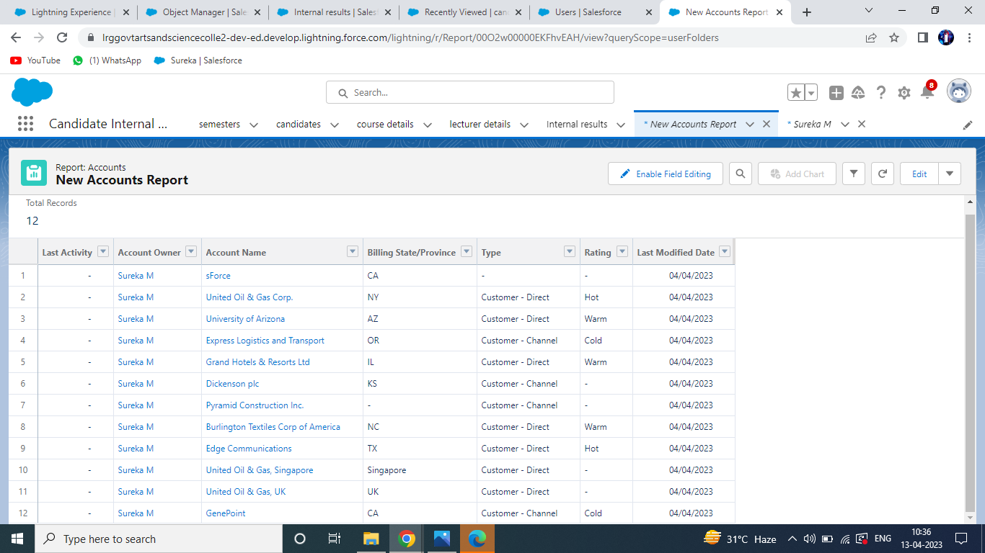

**MILESTONE 6**

Dashboard

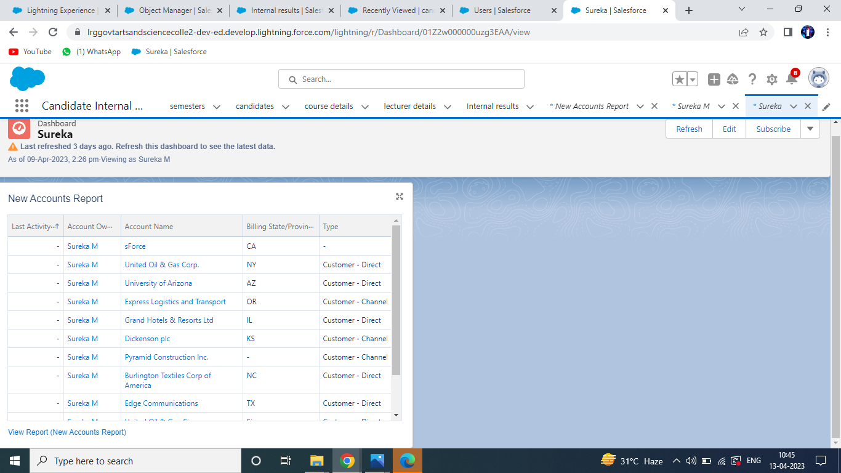

**4 Trailhead Profile Public URL**

Team Leader - <https://trailblazer.me/id/surem37>

Team Member 1 -<https://trailblazer.me/id/shals55>

Team Member 2 -<https://trailblazer.me/id/rathp4>

Team Member 3 –<https://trailblazer.me/id/pthangaraj8>

**5 ADVANTAGES & DISADVANTAGE**

ADVANTAGES:

* A CRM system provides a centralized database for candidate information ,making it easier to track their progress ,results ,and feedback in one place
* By using a CRM system , you can personalize your communication with candidates ,providing them with tailored feedback and learning experience based on their needs and interests.

DISADVANTAGES:

* Implementing and maintaining CRM system can be expensive , especially for smaller organization .
* Technical difficulties and errors can be occur when using a CRM system , which can lead to inaccuracies in candidate data and results.

**6 APPLICATIONS**

* Educational institutions such as universities , colleges and training providers can use a CRM system to track candidate progress and results , provide personalized feedback , and identify areas for improvement.
* Corporate training programs can use a CRM system to track employee progress , identify skill gaps ,and provide targeted learning experiences.

**7 CONCLUSION**

Implementing a CRM system for result tracking of a candidate with internal marks can provide numerous benefits to an organization. By maintaining a centralized data base , monitoring candidate progress , personalizing communication ,and improving the candidate experience , a CRM system can help organizations to better manage candidate interactions and ultimately achieve their goals. Therefore , it’s worth considering the implementation of a CRM system as a tool for tracking and analyzing candidate performance and results.

**8 FUTURE SCOPE**

* By using CRM system to track and analyze candidate interactions , you can identify areas where your organization can improve the candidate experience , such as by providing more timely and relevant feedback.
* Implementing a CRM system for result tracking of a candidate with internal marks can help your organization to better manage candidate interactions , improve communication and feedback , and ultimately , enhance the candidate experience.